

Dear Friends,

The Akron Tiger Football Program is putting together our program for the next football season

To be distributed at our Varsity and JV games. We ask you for your support and hope that you

can help us again this year.

The program will highlight our players on the Varsity, JV, our Cheerleaders, and it offers history

of the team from previous years. We would like to include your ad as well

Please consider putting a player shout out or an advertisement in our program

Examples are shown at the bottom

**Deadline is July 1st**

We look forward to highlighting past and future events in our programs, in addition to encourage

this year’s team.

Thank you in advance for your overwhelming support of the Akron Tigers Football Program!

Please call, text or email me with any questions.

Andrew Clouse - Head Coach - 716-713-6632 – [aclouse@akronk12.org](mailto:aclouse@akronk12.org)

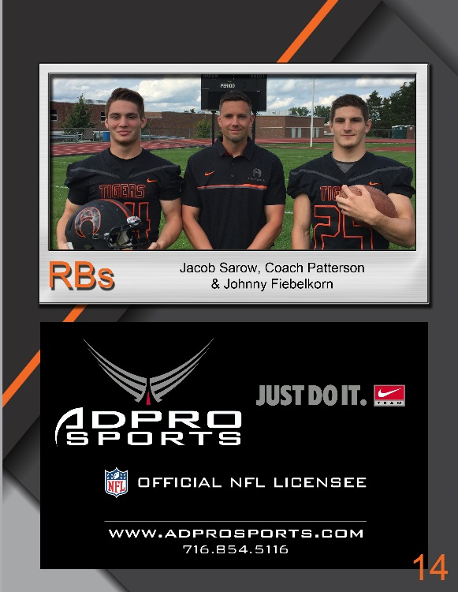

1/2 Page 8 x 5.5

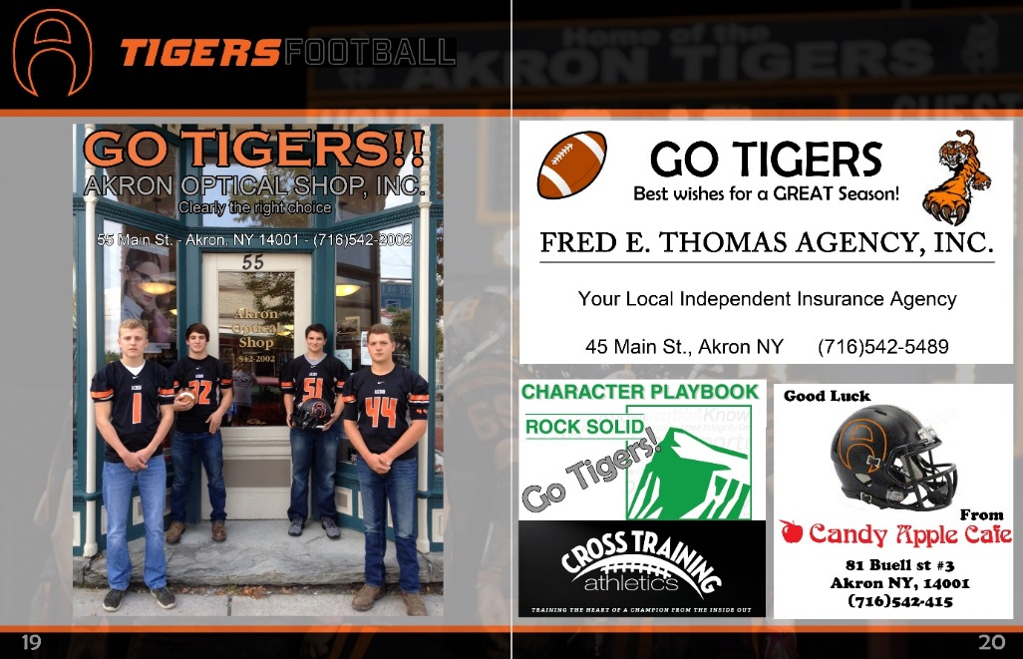

Full Page 8 x 11.5 1/4 Page 4 x 5.5

Akron Tigers Football

2019 Season program

Patron Order Form

Business/Family Name ________________________________________________

Address ____________________________________________________________

City ____________________________ Zip _______________________________

Phone Number _______________________________________________________

E-Mail _____________________________________________________________

Contact Name _______________________________________________________

***Deadline July 1st!***

Full Page (8x11.5) $100 Donation __________

½ Page (8x5.5) $50 Donation __________

¼ Page (4x5.5) $25 Donation __________

½ Page Senior Ad $FREE __________

We must have an Ad Copy, Pictures, Player info, Business info with your order by July 1st.

If you need any assistance or have any questions, please call Andrew Clouse @ 716-713-6632

or email at [aclouse@akronk12.org](mailto:aclouse@akronk12.org)

Please make checks payable to: **Akron Varsity Football**

Mail to: Akron Football

Andrew Clouse

9272 Griswold St

Akron, NY 14001